**Students**

1. **Create Student**
   * **Method:** POST
   * **Endpoint:** /students
   * 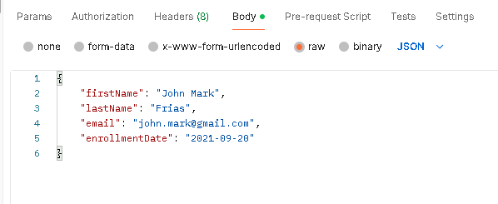**Request Body:**

**Response:**

* **Status:** 201 Created
* **Body:**

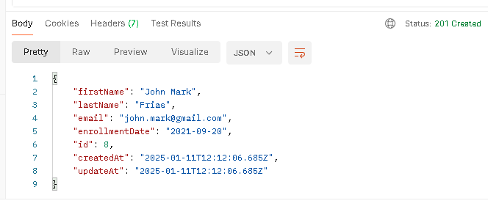

1. **Read Student (Get All Data)**
   * **Method:** GET
   * **Endpoint:** /students
   * **Request Body:** 200 OK

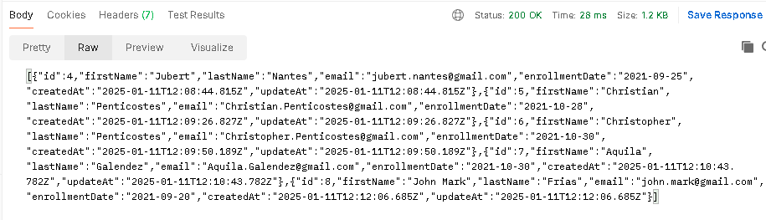

1. **Read Student (Get One)**
   * **Method:** GET
   * **Endpoint:** /students/5
   * **Request Body:** 200 OK

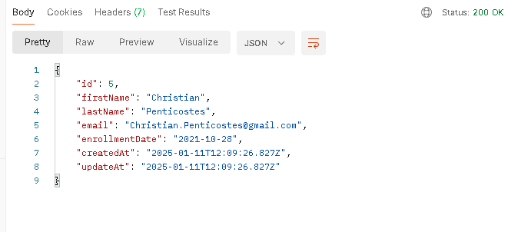

1. **Update Student**
   * **Method:** PUT
   * **Endpoint:** /students/5
   * **Request Body:**

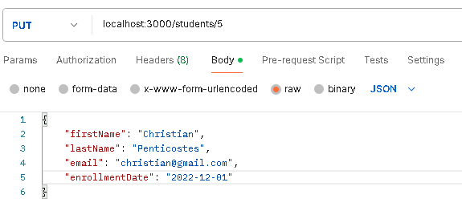

**Response:**

* **Status:** 200 OK
* **Body:**

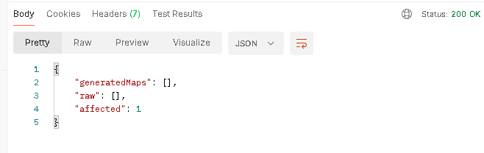

1. **Delete Student**
   * **Method:** DELETE
   * **Endpoint:** /students/6
   * **Request Body:**

